Problems digitale kredsløb

Kapitel 1
$$2^{15}=32.768$$
$$2^{26}=67.108.864$$
$$2^{36}·{10}^{-1}=6.871.947.673,6$$
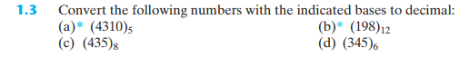
- ${\left(4310\right)}_{5}=0·5^{0}+1·5^{1}+3·5^{2}+4·5^{3}=580$
- ${\left(198\right)}_{12}=8·{12}^{0}+9·{12}^{1}+1·{12}^{2}=260$
- ${\left(435\right)}_{8}=5·8^{0}+3·8^{1}+4·8^{2}=285$
- ${\left(345\right)}_{6}=5·6^{0}+4·6^{1}+3·6^{2}=137$
$$2^{16}-1=65535$$
$${\left(65535\right)}_{10}$$
$${\left(FFFF\right)}_{16}$$
- $\frac{\left(4+1·b\right)}{2}=5$
$⇕$ Ligningen løses for x vha. CAS-værktøjet WordMat.
$$b=6$$
Altså base 6
- $\frac{\left(4+5·b\right)}{4}=3+b$
$⇕$ Ligningen løses for x vha. CAS-værktøjet WordMat.
$$b=8$$
Altså base 8
- $(4+2·b)+(7+b)=4·b$
$⇕$ Ligningen løses for x vha. CAS-værktøjet WordMat.
$$b=11$$
Altså base 11

$$x≔3$$
$$x^{2}-\left(1+b\right)·x+\left(2+2·b\right)=0$$
$⇕$ Ligningen løses for b vha. CAS-værktøjet WordMat.
$$b=8$$
$$Slet definitioner:$$
Altså base 8
$$x≔6$$
$$x^{2}-\left(1+b\right)·x+\left(2+2·b\right)=0$$
$⇕$ Ligningen løses for b vha. CAS-værktøjet WordMat.
$$b=8$$
$$Slet definitioner:$$
Altså base 8
$${\left(64CD\right)}_{16}=0110010011001101$$
$${\left(62315\right)}_{8}$$
$$431$$ | 1
$$\frac{430}{2}=215$$ | 1
$$\frac{214}{2}=107$$ | 1
$$\frac{106}{2}=53$$ | 1
$$\frac{52}{2}=26$$ | 0
$$\frac{26}{2}=13$$ | 1
$$\frac{12}{2}=6$$ | 0
$$\frac{6}{2}=3$$ | 1
$$\frac{2}{2}=1$$ | 1
$$\frac{0}{2}$$ | 0
$$431$$ | 15
$$\frac{416}{16}=26$$ | 10
$$\frac{16}{16}=1$$ | 1
- $431={\left(110101111\right)}_{2}$

- $431={\left(1AF\right)}_{16}={\left(11010111\right)}_{2}$

Ved større numre, er det nemmere at omregne til hexadecimal og så til binært

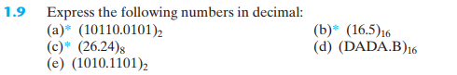
- ${\left(10110.0101\right)}_{2}=2^{1}+2^{2}+2^{4}+2^{-2}+2^{-4}=22,3125$
- ${\left(16.5\right)}_{16}=6·{16}^{0}+1·{16}^{1}+5·{16}^{-1}=22,3125$
- ${\left(26.24\right)}_{8}=6·8^{0}+2·8^{1}+2·8^{-1}+4·8^{-2}=22,3125$
- ${\left(DADA.B\right)}_{16}=10·{16}^{0}+13·{16}^{1}+10·{16}^{2}+13·{16}^{3}+11·{16}^{-1}=56026,6875$
- ${\left(1010.1101\right)}_{2}=2^{1}+2^{3}+2^{-1}+2^{-2}+2^{-4}=10,8125$
- ${\left(1.10010\right)}_{2}={\left(1.9\right)}_{16}=2^{0}+2^{-1}+2^{-4}={\left(1,5625\right)}_{10}$
- ${\left(110.010\right)}_{2}={\left(6.4\right)}_{16}=2^{1}+2^{2}+2^{-2}={\left(6,25\right)}_{10}$
- Well, when we move the dot in decimal numbers, we mutibly with ${10}^{x},$ so it makses sense, the same rule aply to binary, we move the dot two times, we have to mutibly with $2^{2}=4$
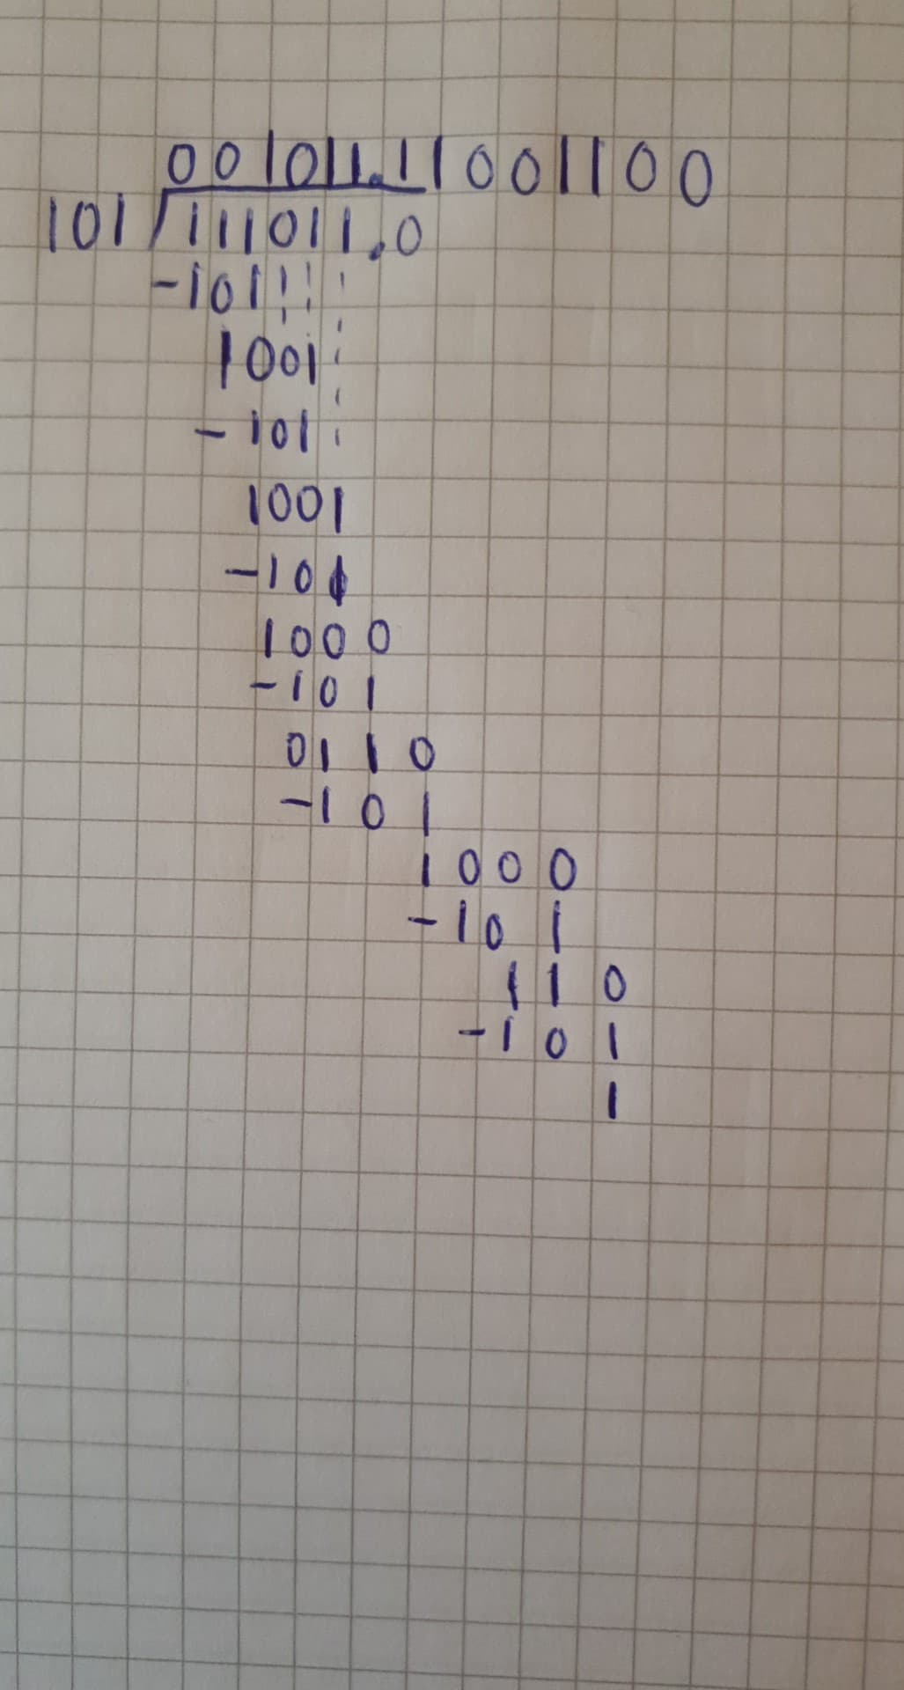
Ligesom normal division
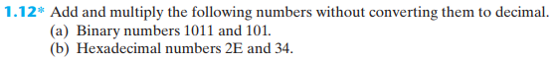
- ${\left(1011\right)}_{2}+{\left(101\right)}_{2}={\left(10000\right)}_{2}$
$${\left(1011\right)}_{2}·{\left(101\right)}_{2}={\left(1011\right)}_{2}+{\left(101100\right)}_{2}={\left(110111\right)}_{2}$$
- ${\left(2E\right)}_{16}+{\left(34\right)}_{16}={\left(62\right)}_{16}$
$${\left(2E\right)}_{16}·{\left(34\right)}_{16}={\left(B8\right)}_{16}+{\left(8A0\right)}_{16}={\left(958\right)}_{16}$$

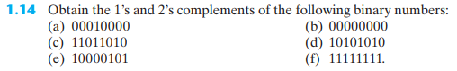
- $1^{'}s:11.111.111-00.010.000=11.101.111$
$$2^{'}s:11.101.111+1=11.110.00$$
- $1^{'}s:11.111.111-00.000.000=11.111.111$
$$2^{'}s:11.111.111+1=100.000.000$$
- $1^{'}s:11.111.111-11.011.010=00.100.101$
$$2^{'}s:00.100.101+1=00.100.110$$

Kapitel 2
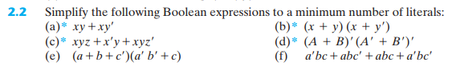
- $xy+x\overline{y}=x·\left(y+\overline{y}\right)=x·1=x$
- $\left(x+y\right)·\left(x+\overline{y}\right)=xx+y\overline{y}+x\overline{y}+xy=x+xy+x\overline{y}=x+x·\left(y+\overline{y}\right)=x+x=x$
- $xyz+\overline{x}y+xy\overline{z}=y\left(xz+\overline{x}+x\overline{z}\right)=y(\overline{x}+x\left(z+\overline{z}\right)=y\left(\overline{x}+x\right)=y$
- $\overline{A+B}·\overline{\left(\overline{A}+\overline{b}\right)}=\overline{A}\overline{B}AB=0$
- $\left(a+b+\overline{c}\right)\left(\overline{a}\overline{b}+c\right)=\overline{a}\overline{b}\overline{c}+ac·bc$
- $\overline{a}bc+ab\overline{c}+abc+\overline{a}b\overline{c}=b\left(\overline{a}c+a\overline{c}+ac+\overline{a}\overline{c}\right)=b\left(\overline{a}\left(c+\overline{c}\right)+a\left(c+\overline{c}\right)\right)=b\left(\overline{a}+a\right)=b$

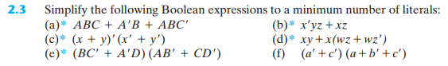
- $ABC+\overline{A}B+AB\overline{C}=B\left(AC+\overline{A}+A\overline{C}\right)=B\left(\overline{A}+A\left(C+\overline{C}\right)\right)=B\left(\overline{A}+A\right)=B$
- $\overline{x}yz+xz=z\left(\overline{x}y+x\right)=z\left(\left(x+\overline{x}\right)\left(x+y\right)\right)=z\left(x+y\right)=zx+zy$
- $\overline{x+y}·\left(\overline{x}+\overline{y}\right)=\left(\overline{x}\overline{y}\right)\left(\overline{x}+\overline{y}\right)=\overline{x}\overline{y}$
- $xy+x\left(wz+w\overline{z}\right)=xy+xw$
- $\left(B\overline{C}+\overline{A}D\right)\left(A\overline{B}+C\overline{D}\right)=0$
- $\left(\overline{a}+\overline{c}\right)\left(a+\overline{b}+\overline{c}\right)=\overline{a}\overline{b}+\overline{a}\overline{c}+a\overline{c}+\overline{b}\overline{c}+\overline{c}=\overline{a}\overline{b}+\overline{c}\left(\overline{a}+a+\overline{b}\right)=\overline{a}\overline{b}+\overline{c}\left(1+\overline{b}\right)=\overline{a}\overline{b}+\overline{c}$
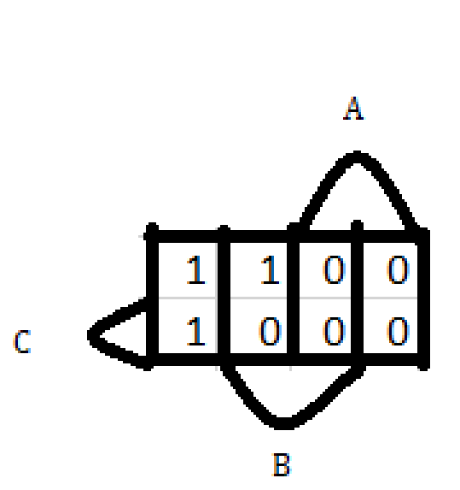
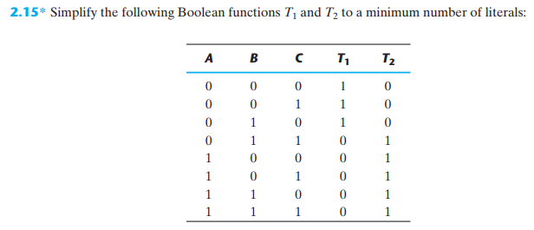
Lav k map
$$T_{1}=\overline{A}\overline{C}+\overline{A}\overline{B}$$
$$T_{2}=A+BC$$

X | Y | Z | W | F
0 | 0 | 0 | 0 | 0
0 | 0 | 0 | 1 | 0
0 | 0 | 1 | 0 | 1
0 | 0 | 1 | 1 | 1
0 | 1 | 0 | 0 | 0
0 | 1 | 0 | 1 | 1
0 | 1 | 1 | 0 | 0
0 | 1 | 1 | 1 | 1
1 | 0 | 0 | 0 | 0
1 | 0 | 0 | 1 | 0
1 | 0 | 1 | 0 | 1
1 | 0 | 1 | 1 | 1
1 | 1 | 0 | 0 | 1
1 | 1 | 0 | 1 | 1
1 | 1 | 1 | 0 | 1
1 | 1 | 1 | 1 | 1
$$F=x\overline{y}z+\overline{x}\overline{y}z+\overline{w}xy+w\overline{x}y+wxy=z\left(x\overline{y}+\overline{x}\overline{y}\right)+y\left(\overline{w}x+w\overline{x}+wx\right)=z\left(\overline{y}\left(\overline{x}+x\right)\right)+y(x\left(w+\overline{w}\right)+w\overline{x}=z\overline{y}+y\left(x+w\overline{x}\right)=z\overline{y}+y\left(\left(x+w)(x+\overline{x}\right)\right)=z\overline{y}+yx+yw$$
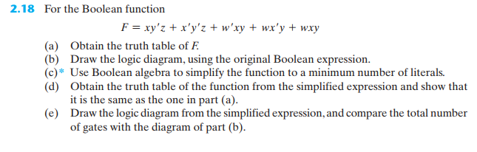

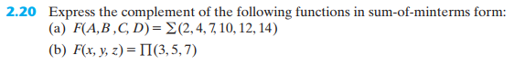
- $\overline{F}\left(A,B,C,D\right)=∑\left(0,1,3,5,6,8,9,11,13,15\right)$
- $\overline{F}\left(x,y,z\right)=∑\left(3,5,7\right)$

$$\left(b+d\right)\left(\overline{a}+\overline{b}+c\right)=\overline{a}b+\overline{a}d+bc+\overline{b}d+cd$$
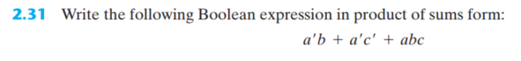
$$F=\overline{a}b+\overline{a}\overline{c}+abc$$
$$\overline{F}=\overline{\left(\overline{a}b+\overline{a}\overline{c}+abc\right)}=\overline{\overline{a}b}·\overline{\overline{a}\overline{c}}·\overline{abc}=\left(a+\overline{b}\right)·\left(a+c\right)·\left(\overline{a}+\overline{b}+\overline{c}\right)$$
$$=\left(a+\overline{b}c\right)·\left(\overline{a}+\overline{b}+\overline{c}\right)=a\overline{b}+a\overline{c}+\overline{a}\overline{b}c+\overline{b}c=a\overline{b}+a\overline{c}+\overline{b}c$$
$$F=\overline{\left(a\overline{b}+a\overline{c}+\overline{b}c\right)}=\overline{\left(a\overline{b}\right)}·\overline{\left(a\overline{c}\right)}·\overline{\left(\overline{b}c\right)}=\left(\overline{a}+b\right)·\left(\overline{a}+c\right)·\left(b+\overline{c}\right)$$

Kapitel 3
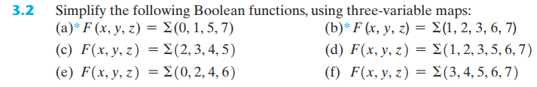
 | a) |  | X
 | 1 | 0 | 0 | 0
Z | 1 | 0 | 1 | 1
 |  | Y
 | b) |  | X
 | 0 | 1 | 1 | 0
Z | 1 | 1 | 1 | 0
 |  | Y
- $\overline{x}\overline{y}+xz$
- $y+\overline{x}z$
- $\overline{x}y+x\overline{y}=x⨁y$
- $y+z$
- $\overline{z}$
- $x+yz$
 | d) |  | X
 | 0 | 1 | 1 | 0
Z | 1 | 1 | 1 | 1
 |  | Y
 | c) |  | X
 | 0 | 1 | 0 | 1
Z | 0 | 1 | 0 | 1
 |  | Y
 | e) |  | X
 | 1 | 1 | 1 | 1
Z | 0 | 0 | 0 | 0
 |  | Y
 | f) |  | X
 | 0 | 0 | 1 | 1
Z | 0 | 1 | 1 | 1
 |  | Y
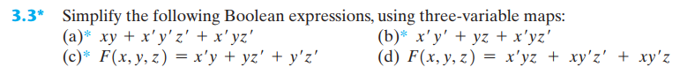
 | a) |  | X
 | 1 | 1 | 1 | 0
Z | 0 | 0 | 1 | 0
 |  | Y
 | b) |  | X
 | 1 | 1 | 0 | 0
Z | 1 | 1 | 1 | 0
 |  | Y
- $xy+\overline{x}\overline{z}$
 | c) |  | X
 | 1 | 1 | 1 | 1
Z | 0 | 1 | 0 | 0
 |  | Y
- $\overline{x}+yz$
- $\overline{z}+\overline{x}y$
 | d) |  | X
 | 0 | 0 | 0 | 1
Z | 0 | 1 | 0 | 1
 |  | Y
- $x\overline{y}+\overline{x}yz$

 | a) |  | X
 | 0 | 1 | 0 | 0
 | 0 | 1 | 0 | 0 | W
Z | 1 | 1 | 1 | 1
 | 1 | 1 | 1 | 1
 |  | Y
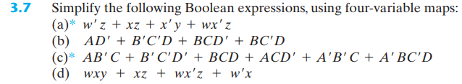
 | b) |  | A
 |  |  | 1 | 1
 | 1 | 1 | 1 | 1 | D
C
 |  | 1 | 1 | 1
 |  | B
- $z+\overline{x}y$
- $A\overline{D}+\overline{C}D+BC\overline{D}$
- $AC+\overline{B}\overline{D}+CD+\overline{A}BD$
- $xy+x\overline{w}+zw$

 | c) |  | A
 | 1 | 0 | 0 | 1
 | 0 | 1 | 0 | 0 | D
C | 1 | 1 | 1 | 1
 | 1 | 0 | 1 | 1
 |  | B
 | d) |  | X
 | 0 | 0 | 1 | 1
 | 0 | 0 | 1 | 0 | W
Z | 1 | 1 | 1 | 1
 | 0 | 0 | 1 | 1
 |  | Y

- $F=A\overline{B}C+AC\overline{D}+\overline{A}\overline{B}\overline{C}+\overline{A}\overline{C}D=AC\left(\overline{B}+\overline{D}\right)+\overline{A}\overline{C}\left(\overline{B}+D\right)$
 |  |  | A
 | 1 | 0 | 0 | 0
 | 1 | 1 | 0 | 0 | D
C | 0 | 0 | 0 | 1
 | 0 | 0 | 1 | 1
 |  | B
- $\overline{F}=A\overline{C}+\overline{A}C+B\overline{C}\overline{D}+BCD=A⨁C+B\left(CD+\overline{C}\overline{D}\right)$
$$F=\overline{\left(A⨁C\right)}·\overline{\left(B\left(CD+\overline{C}\overline{D}\right)\right)}=\overline{A⨁C}·\overline{B}\left(\overline{C}+\overline{D}\right)\left(C+D\right)$$
- $\overline{F}=A\overline{C}+\overline{A}C+B\overline{C}\overline{D}+ABD=A⨁C+B\left(AD+\overline{C}\overline{D}\right)$
$$F=\overline{\left(A⨁C\right)}·\overline{\left(B\left(AD+\overline{C}\overline{D}\right)\right)}=\overline{A⨁C}·\overline{B}\left(\overline{A}+\overline{D}\right)\left(C+D\right)$$

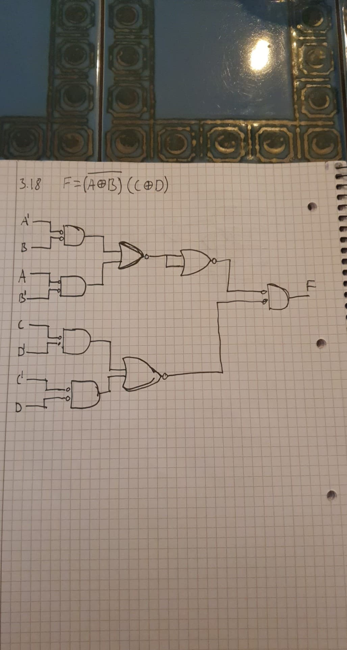
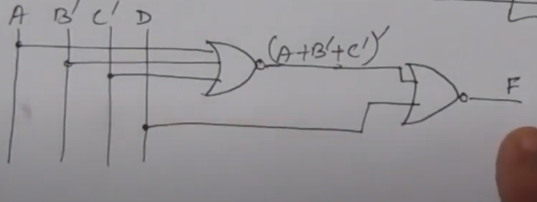
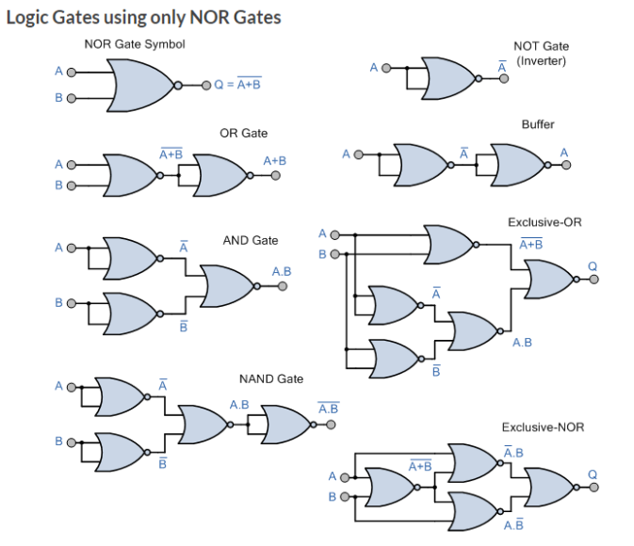
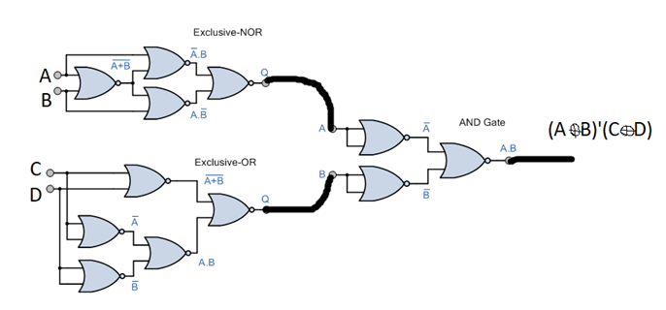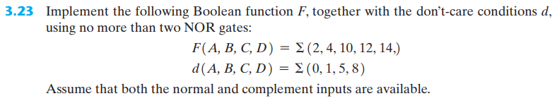
 |  |  | A
 | X | 1 | 1 | X
 | X | X | 0 | 0 | D
C | 0 | 0 | 0 | 0
 | 1 | 0 | 1 | 1
 |  | B
$$F=A\overline{D}+\overline{B}\overline{C}+\overline{C}\overline{D}$$
$$\overline{F}=D+\overline{A}BC$$
$$F=\overline{D+\overline{\left(A+\overline{B}+\overline{C}\right)}}$$

Kapitel 4
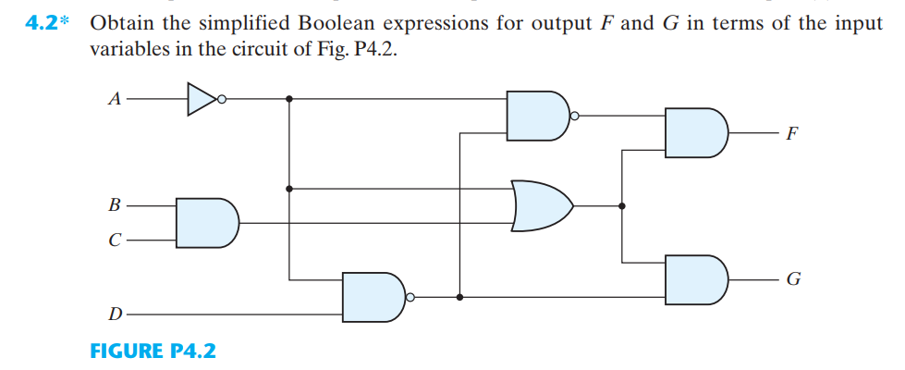
$$F=\overline{\left(\left(\overline{\overline{A}D}\right)\left(\overline{A}\right)\right)}\left(\overline{A}+BC\right)=\left(\overline{\left(\overline{\overline{A}D}\right)}+\overline{\overline{A}}\right)\left(\overline{A}+BC\right)=\left(\left(\overline{A}D\right)+A\right)\left(\overline{A}+BC\right)=\overline{A}D+\overline{A}BCD+0+ABC=\overline{A}D+ABC$$
$$G=\left(\overline{\overline{A}D}\right)\left(\overline{A}+BC\right)=\left(A+\overline{D}\right)\left(\overline{A}+BC\right)=ABC+\overline{A}\overline{D}+BC\overline{D}=ABC+\overline{A}\overline{D}$$
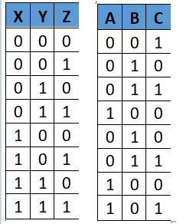
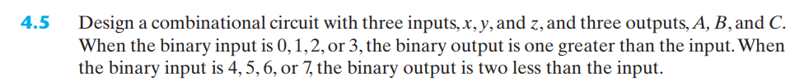
 | a) |  | X
 | 0 | 0 | 1 | 0
Z | 0 | 1 | 1 | 0
 |  | Y
 | b) |  | X
 | 0 | 1 | 0 | 1
Z | 1 | 0 | 0 | 1
 |  | Y
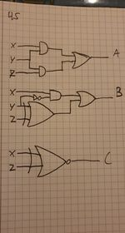
 | c) |  | X
 | 1 | 1 | 0 | 0
Z | 0 | 0 | 1 | 1
 |  | Y

$$A=XY+ZY$$
$$B=X\overline{Y}+(Y⨁Z)$$
$$C=XZ+\overline{X}\overline{Z}=\overline{\left(X⨁Z\right)}$$

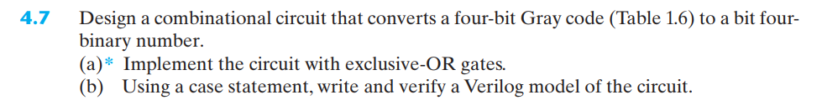
 | A |  | $$G_{3}$$
 | 0 | 0 | 1 | 1
 | 0 | 0 | 1 | 1 | $$G_{0}$$
$$G_{1}$$ | 0 | 0 | 1 | 1
 | 0 | 0 | 1 | 1
 |  | $$G_{2}$$
 | B |  | $$G_{3}$$
 | 0 | 1 | 0 | 1
 | 0 | 1 | 0 | 1 | $$G_{0}$$
$$G_{1}$$ | 0 | 1 | 0 | 1
 | 0 | 1 | 0 | 1
 |  | $$G_{2}$$
 | C |  | $$G_{3}$$
 | 0 | 1 | 0 | 1
 | 0 | 1 | 0 | 1 | $$G_{0}$$
$$G_{1}$$ | 1 | 0 | 1 | 0
 | 1 | 0 | 1 | 0
 |  | $$G_{2}$$
 | D |  | $$G_{3}$$
 | 0 | 1 | 0 | 1
 | 1 | 0 | 1 | 0 | $$G_{0}$$
$$G_{1}$$ | 0 | 1 | 0 | 1
 | 1 | 0 | 1 | 0
 |  | $$G_{2}$$
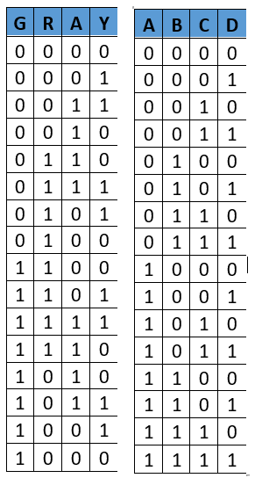

$$A=G_{3}$$
$$B=G_{2}\overline{G_{3}}+\overline{G_{2}}G_{3}=G_{3}⨁G_{2}$$
$$C=G_{3}\overline{G_{2}}\overline{G_{1}}+\overline{G_{3}}G_{2}\overline{G_{1}}+\overline{G_{3}}\overline{G_{2}}G_{1}+G_{3}G_{2}G_{1}=G_{3}⨁G_{2}⨁G_{1}$$
$$D=G_{3}⨁G_{2}⨁G_{1}⨁G_{0}$$

